Welcoming a New Student to the Class
Grade 4 Core French (CEFR: A1)

This work is adapted from "Welcoming a New Student to the Class" by the CEFR Eastern Region Working group, used under CC BY-NC-SA 4.0. "Welcoming a New Student to the Class- Grade 4 Core French (CEFR: A1)" is licensed under CC BY-NC-SA 4.0 by Camerise K-12.

Instructions for Teachers

This resource consists of a collection of Action-oriented (AO) Scenarios created by the CEFR Eastern Region Working Group, designed for use in Ontario French as a Second Language (FSL) classrooms. AO Scenarios are an integral part of the Common European Framework of Reference’s (CEFR) Action-oriented Approach (AoA).

The CEFR and the Action-oriented Approach in the Ontario Context

The CEFR is a complete framework used to support learning, teaching, and assessment of second/additional languages. Developed by the Council of Europe, that continent's leading human rights organization, the CEFR has been translated into 40 languages and is used across the world. In 2010, the Council of Ministers of Education, Canada recommended the use of the CEFR in the Canadian context. In Ontario, concepts of the CEFR are integrated throughout the FSL Curriculum.
“teaching language as a system of disconnected and isolated components gives learners some knowledge of the language, but does not allow them to use the language effectively. In contrast, communicative and action-oriented approaches to teaching French put meaningful and authentic communication at the centre of all learning activities”
(The Ontario Curriculum, FSL, p. 9).
“Communication is a social act. In order to learn French, therefore, students need to see themselves as social [agents] communicating for real purposes”
(The Ontario Curriculum, FSL, p. 9).

The AoA is one of the key concepts of the CEFR. With the AoA, learners are seen as ‘social agents’ (i.e., someone who exerts their own agency to accomplish real-life tasks). Tasks are critical in the AoA as it is the task that provides the purpose for action, and also frames the learning that takes place within the scenario (i.e., learning module) so that the learner can successfully accomplish the task at hand. The AoA moves away from ‘forward design’ in curriculum planning, instead, favouring ‘backward design’ (Piccardo & North, 2019), which involves planning back from action-oriented tasks (see Figure 1).


Figure 1: Components of an Action-oriented Scenario
Development of competences  (includes subtasks) | Action-oriented Task  Backward Design

Using the Resource

All of the original content that has been created can be found on the link CEFR Eastern Region Working Group Website. On the website, you will find information about this group, suggested resources to learn more about the CEFR and the AoA, the above-mentioned AO Scenarios, and information on the Creative Commons licence that applies to the resource.

AO Task support materials include:
- AO Teacher Planning Sheet
  - This document provides a description of the task, connections to the Ontario Curriculum, and CEFR descriptors / Student friendly “I can” statements
- AO Task Student View
  - This document provides the AO Task in French, in a student-friendly format
- Assessment Tools
  - Assessment tools are provided to evaluate the components of the AO Task
- Student Planning Sheet
  - This document allows students to monitor their learning throughout the AO Scenario. It is also to be used as a Universal Design for Learning strategy whereby students can ‘chunk’ their learning into more manageable pieces
- Threads
  - Around the AO Task and support materials are different threads. These threads illustrate clusters of possible competences to be developed during the AO Scenario to support students in successfully completing the AO Task. Each thread consists of a table composed of possible subtasks that are designed to build competences connected to a particular area of learning. This table includes links to ready-to-use and/or modify resources, the ‘I can’ statements being targeted, the CEFR communicative language activities and competences that are most prevalent for the sub-task, and possible assessment opportunities based on the four skills of FSL Ontario Curriculum (i.e., Speaking, Listening, Reading, Writing).

IMPORTANT: The threads and the possible subtasks are not presented in any order, and are not intended to be a step-by-step method to planning (unless it is connected to a publisher program). In fact, it is quite the contrary. Key principles of the AoA stipulate that teaching and learning are non-linear, flexible, and dynamic (i.e., changes over time). It is with this in mind that the threads and possible subtasks are presented more like a “bouquet” (Piccardo & North, 2019) whereby teachers pick and choose the ‘flowers’ (i.e., the threads and subtasks) that they would like to include in their bouquet for their students. Students can also play a role in determining the ‘flowers’ to add to the bouquet when sub-tasks are co-created by the teacher and the students.

Expanding the AO Scenario Webs
In keeping with the spirit of collaboration, teachers are invited to contribute other possible subtasks using this Google Form, which will be added to the resource (funding dependent). Contributions need to be compliant with copyright laws, with special attention paid to the images used (it is recommended that teachers only use images from the Canva Education licence and that the source be indicated next to the images), and the links provided (do not take screenshots of materials and include them in the submission. Instead, provide a direct link to the resource).

Here is a resource related to copyright, and Creative Commons: Creative Commons - Share your Work

Project Overview
In this project, students will use their learning to perform Action-oriented Tasks, based on modules from Pearson’s program for Grade 4 Core French students, Échos Pro 1. To acquire the precise competences necessary to complete these tasks, students will engage in a series of sub-tasks designed to guide, support and prepare them as they work towards achieving real-life goals (see Figure 2). In this way, students see that their learning has a genuine and authentic purpose, that their French competences actually give them the ability to achieve something tangible in the real world.

Échos Pro
Sub-tasks
Action-
Oriented
Task

Figure 2

Learning aligns with the Ontario FSL Curriculum for Core French, the Common European Framework of Reference (CEFR), and Pearson’s Échos Pro program.

Program | Ontario FSL Curriculum for Core French | CEFR Levels
Échos Pro 1 | Grade 4 | A1

Suggested Steps in Using this Resource
Preparing Students to be able to Complete the Action-oriented Tasks:
- Keep in mind that Action-oriented Tasks require the students to be “social agents” - in other words, the students act on their own accord to make things happen through tasks. Most often in a classroom setting, this looks like students engaging in a role-play (not scripted) of a task that could happen in real-life.
- It is preferable that the teacher uses the Échos Pro 1 Teacher’s Guide and student texts, in tandem with the sub-tasks, to develop the students’ competences in preparation for the Action-oriented Task.
- While students are engaged in the sub-tasks, there will be multiple occasions to review and consolidate their learning from the Échos Pro 1 modules.
- It is important to follow the principles of the Gradual Release of Responsibility model (written in the Teacher’s Guides as Modelled Practice, Shared Practice, Guided Practice and Independent Practice).
- Suggestions to support the principles of the Universal Design for Learning are included in the Teacher’s Guides.
- Furthermore, the Student Planning Graphic Organizers provide support to ALL students as they complete the Action-oriented Tasks.
- To provide students with an editable version of a “View only” Google slide or document, just “Make a copy” of the slide or document.

Organization of the Resource
Grade 4 Resource: Échos Pro 1 – Module 1: Ma classe et moi
Scenario: Welcoming a new student to the class
Sub-tasks:
- Sharing Personal Information
- Expressing School Subject Preferences
- Expressing Colour Preferences
- Sharing Personal Information of Others
- Engaging in Conversation with Others

Assessment
It is up to teachers to determine whether the sub-tasks are assessments FOR learning, OF learning, or AS learning.

The assessment tools provided are presented in this document, in the next pages.

Program | Student Planning Graphic Organizers | Assessment OF Learning
Échos Pro 1 | Planning Sheet: Interaction orale  Planning Sheet: Production écrite | Évaluation : Interaction orale  Évaluation : Production écrite

Assessment OF Learning
The Student Planning Graphic Organizers (assessment as learning tool) allow students to plan and consolidate their learning as they focus on what is required of them to successfully complete the Action-oriented Tasks. In order to provide supportive language for ALL students, reference pages are included within the Graphic Organizers for students to use as necessary. The teacher will then evaluate the various elements of the Action-oriented Tasks using the Evaluation sheets provided. Some tasks may require students to present independently, while others could require some kind of interaction with a partner or in small groups. Students should be offered options when creating the written, such as the option to create the task electronically (e.g. Canva, Google Docs, Google Slides) or in various formats by hand.

Equity Considerations
Creating a space that is inclusive, safe and equitable for ALL students is key. It is important to understand what the students bring to the learning experience and honour their identity. Pearson’s modules contain visuals of students of diverse backgrounds, so that the students can “see” themselves in the texts. These resources enable and encourage the students to share their own cultural backgrounds, languages and experiences. The language used when completing these tasks should be inclusive, accessible and age-appropriate. Providing additional tools to support the success of ALL students is a necessary component in the students' learning journey.

Support Material

AO Teacher Planning Sheet
Template modified from: Hunter, D., Cousineau, D., Collins, G., & Hook, G. (2019). Action-oriented Approach Handbook. Canadian Association of Second Language Teachers.

Scenario: Welcoming a new student to the class
Program: Échos Pro 1 | Grade Level: 4 Core French
Module: Ma classe et moi | CEFR Level: A1
Checklist:  - Learners are “social agents” in an authentic collaborative social context  - Action is purposeful with real-world applications  - There is a clearly communicated goal to be accomplished that results in a product or outcome  - Learning is supported by authentic, real-life texts and experiences  - There are conditions and constraints that promote critical and creative thinking  - Learners draw upon their existing and newly developed competences  - Learners make choices and think and act strategically | Additional Elements:  - Human Rights  - Equity  - Diversity  - Inclusion  - Universal Design for Learning  - Plurilingualism (Competences)  - Pluriculturalism (Competences)
Action-oriented Task:
A new student arrives in your class from another country. The student speaks a little French, but no English. To help the student feel welcome, you say a few words to them in their language. As you both speak a little French, you ask the student to join you at recess so that you can get to know each other, sharing some personal information and basic preferences. You also introduce the student to your friends. After recess, the new student asks you what subject is next. Help them find their backpack which has their timetable in it and make sure that they know the order of the school subjects for the rest of the day. Later in class, the teacher asks everyone to complete a get-to-know-you questionnaire. You fill out the form and also help your new friend to fill it out too.

Note: This task is also available in a student view version, ready to be shown in class.
Learning Outcomes/Overall Expectations:
A1. Listening to Understand: demonstrates an understanding of the purpose and meaning of oral French texts containing familiar words and expressions about everyday topics and situations
B2. Speaking to Interact: engages in brief, structured spoken interactions, using familiar words and expressions
C1. Reading for Meaning: demonstrates an understanding of French texts, containing visuals and familiar names, words and phrases
D1. Writing in a Variety of Forms: write a French text, applying their knowledge of basic structural and stylistic elements of a questionnaire

Communicative Language Activities/Strategies (WHAT?)
Reception, Production, Interaction, Mediation
CEFR Descriptors | Student-friendly “I can” Statements
Reception:  (Oral comprehension; Understanding conversation between other people)  Can understand some expressions when people are discussing them, family, school, hobbies or surroundings, provided the delivery is slow and clear.  (Reading comprehension; Overall reading comprehension)  Can understand very short, simple texts, a single phrase at a time, picking up familiar names, words and basic phrases and rereading as required.  Interaction:  (Oral production; Addressing audiences)  Can make an introduction and use basic greeting and leave-taking expressions.  (Oral production; Sustained monologue: describing experience)  Can ask and answer simple questions about themselves and other people, where they live, people they know, things they have.  (Written production; Overall written production)  Can fill in numbers and dates, own name, nationality, address, age, date of birth or arrival in the country, etc., e.g. on a hotel registration form.  Mediation:  (Mediating concepts; Collaborating to construct meaning)  Can collaborate to express ideas and understand using simple words and phrases  (Mediating communication; Facilitating a pluricultural space)  Can facilitate an intercultural exchange by showing a welcoming attitude and interest with simple words/signs and non-verbal signals, by inviting others to contribute, and by indicating whether they understand when addressed directly. | Je peux comprendre mes amis quand ils se présentent et parlent de leurs préférences.  I can understand my friends when they introduce themselves and talk about their preferences.  Je peux comprendre les questions sur un questionnaire personnel.  I can understand the questions on a get-to-know-you questionnaire.  Je peux me présenter et utiliser des phrases de salutation et de prise de congé simples.  I can introduce myself and use basic greeting and leave-taking expressions.  Je peux poser des questions au sujet de mes amis et répondre à leurs questions.  I can ask questions about my friends and can answer their questions.  Je peux remplir un questionnaire personnel.  I can fill in a questionnaire about myself and my preferences.  Je peux comprendre un texte.  I can understand a text.  Je peux parler d’un texte.  I can talk about a text.  Je peux souhaiter la bienvenue à un nouvel ami et lui offrir de l'aide.  I can make a new friend feel welcome and help them with simple tasks.

Communicative Language Competences (HOW?)
Linguistic, Socio-linguistic, Pragmatic
CEFR Descriptors | Student-friendly “I can” Statements
Linguistic:  (Linguistic competence; General linguistic range)  Has a very basic range of simple expressions about personal details and needs of a concrete type.  (Linguistic competence; Vocabulary range)  Has a basic vocabulary repertoire of words/signs and phrases related to particular concrete situations.  (Linguistic competence; Overall phonological control)  Can reproduce correctly a limited range of sounds as well as stress for simple, familiar words and phrases.  (Linguistic competence; Orthographic control)  Can spell their address, nationality and other personal details.  (Linguistic competence: Grammatical accuracy)  Shows only limited control of a few simple grammatical structures and sentence patterns in a learnt repertoire.  Pragmatic:  (Pragmatic competence; Turntaking)  Can take turns with an interlocutor during a simple conversation.  Socio-linguistic:  (Sociolinguistic competence; Sociolinguistic appropriateness)  Can respond appropriately in conventionalised interactions, e.g. replying with a formulaic <welcome>. | Je peux utiliser des phrases pour donner des détails simples au sujet de moi.  I can use language structures to give simple details about myself in a conversation.  Je peux utiliser le vocabulaire simple pour parler de moi et aider mon ami à remplir son questionnaire.  I can use basic vocabulary to talk about myself and help a friend fill out their questionnaire.  Je peux prononcer correctement les mots familiers.  I can pronounce familiar words correctly.  Je peux épeler correctement quand j'écris des informations simples au sujet de moi et de mes préférences.  I can spell correctly when I write basic information about myself and my preferences.  Je peux écrire correctement au présent  I can write in the present tense correctly.  Je peux parler à tour de rôle avec un ami.  I can take turns when speaking with a friend.  Je peux répondre de manière respectueuse et appropriée.  I can respond respectfully and appropriately.

Plurilingual and Pluricultural Competence
Building on pluricultural repertoire, Plurilingual comprehension, Building on plurilingual repertoire
Please see p.123 of the CEFR (2020) for descriptors to use as part of overall learning/teaching to incorporate the learner’s full plurilingual repertoire.
CEFR Descriptors | Student-friendly “I can” Statements
Plurilingual:  (Building on plurilingual repertoire)  Can use a very limited repertoire in different languages to conduct a very basic, concrete, everyday transaction with a collaborative interlocutor.  Pluricultural:  (Facilitating pluricultural space)  Can facilitate an intercultural exchange by showing a welcoming attitude and interest. | Je peux saluer mon ami en utilisant quelques mots dans sa langue.  I can greet my friend using a few words in their language.  Je peux souhaiter la bienvenue à mes nouveaux amis et leur montrer de l'intérêt.  I can welcome new friends and show an interest in them.

AO Task Student View

Évaluation – Interaction orale
Grade 4 Core French (A1) - Scenario: Welcoming a new student to class. Nom : ………….
 | Category | Criteria | Achievement Level/Grade  (E.g., Level 1-4, /10) | Comments
Application | Interaction (Conversation) | - I can participate in a short, brief conversation  - I can introduce myself and introduce my friends  - I can ask and answer questions  - I can say what I like and what my friends like
Communication | Linguistic Competence | - I can use simple grammatical structures and sentence patterns seen in class (General linguistic range)  - I can use basic vocabulary (Vocabulary range)
Communication | Sociolinguistic Competence | - I can greet someone politely in a conversation  - I can respond to questions appropriately and respectfully
Communication | Pragmatic Competence | - I can take turns when speaking with a friend (Turntaking)  - I can say the words and sentences seen in class with some fluency
Communication | Phonological Control | - I can correctly pronounce words and phrases that we learned in class
Knowledge/  Understanding | Content | - I can invite a friend to join me  - I can get to know someone  - I can give basic personal information about myself  - I can give basic personal information about my friends  - I can describe my preferences  - I can describe my friends’ preferences  - I can discuss the class timetable
Thinking | Mediation / Plurilingualism | - I can make a new friend feel welcome  - I can show interest, and invite others to contribute  - I can use a very limited repertoire in different languages
Thinking | Reasoning | - I can determine what is most important to share about myself in a short conversation
Thinking | Planning | - I can use the Student Planning Graphic Organizer to help me communicate effectively

Évaluation – Production écrite
Grade 4 Core French (A1) - Scenario: Welcoming a new student to class. Nom : ………….
 | Category | Criteria | Achievement Level/Grade  (E.g., Level 1-4, /10) | Comments
Application | Interaction (Written correspondence) | - I can respond to a questionnaire asking for my personal information
Communication | Linguistic Competence | - I can provide personal information using familiar words  - (Vocabulary range)  - I can spell correctly when I write basic information about myself and my preferences (Orthographic control)  - I can use simple sentence patterns (e.g. Je m’appelle …, J’aime …) correctly (Grammatical accuracy)
Communication | Sociolinguistic Competence | - I can respond to questions in an appropriate manner
Communication | Pragmatic Competence | - I can link words or groups of words with very basic linear connectors (e.g. “and”)  - I can communicate basic information in a simple way
Knowledge/  Understanding | Content | - I can give the following personal information:  - my name  - my age  - my favourite colour  - my favourite subject  - colour of my backpack  - ways that I say “hello” in different languages
Thinking | Mediation / Plurilingualism | - I can express my ideas using simple words and phrases  - I can use a very limited repertoire in different languages
Thinking | Reasoning | - I can determine what is most important to share about myself
Thinking | Planning | - I can use the Student Planning Graphic Organizer to help me communicate effectively

Student Planning Sheet – Interaction orale
Grade 4 Core French (A1) - Échos Pro 1 – Module 1 : Ma classe et moi

Étapes de la collaboration :
- Je peux répondre aux questions.
- Je peux poser des questions.
- Je peux participer à une conversation avec politesse.
- Je peux parler à tour de rôle dans une conversation.

1/ Page pour mobiliser les connaissances
La structure | Des phrases utiles
Saluer
Mon nom
Mon âge
Ma matière préférée
Ma couleur préférée
Mes questions
Présenter mon ami.e
Inviter mon ami.e
Offrir de l’aide
Mon horaire
Prise de congé

Student Planning Sheet – Interaction orale
Grade 4 Core French (A1) - Échos Pro 1 – Module 1 : Ma classe et moi

2/ Page de référence
La structure | Des phrases utiles
Pour saluer | Bonjour !  Salut !  Hola ! | Marhaba !  Ciao !  Ni hao !
Pour être poli | Merci | S’il vous plaît
Pour me présenter | Je m’appelle …  J’ai ... ans.  Je dis …
Pour parler de mes préférences | J’aime …
Pour poser des questions personnelles | Comment t’appelles-tu ?  Quel âge as-tu ?  Comment est-ce que tu dis “bonjour” ?  Quelle matière est-ce que tu aimes ?  Quelle couleur est-ce que tu aimes ?
Pour présenter mon ami.e | Voici mon ami.e !  Mon ami.e s’appelle …
Pour inviter mon ami.e | C’est la récré.  Est-ce que tu veux jouer avec moi ?
Pour offrir de l’aide | Est-ce que je peux t’aider ?  Où est ton horaire ?  De quelle couleur est ton sac à dos ?
Pour parler de l’horaire | À 10h00, c’est …  Après la récré, c’est …  Après …, c’est …
Pour dire les phrases de prise de congé simples | Au revoir !  À demain !  À plus tard ! | À la prochaine !  À bientôt !

Student Planning Sheet - Production écrite
Grade 4 Core French (A1) - Échos Pro 1 – Module 1 : Ma classe et moi

Un questionnaire pour se présenter
Réponds aux questions suivantes en utilisant des phrases complètes.
La question | Ta réponse
1. Comment t’appelles-tu ?

2. Quel âge as-tu ?

3. Quelle matière est-ce que tu aimes ?

4. Quelle couleur est-ce que tu aimes ?

5. Quelle couleur est ton sac à dos ?

6. a. Quelles langues est-ce que tu parles
(même un petit peu) ?
b. Comment est-ce qu’on dit “bonjour”
dans ces langues ?

Threads
Resources suggested in the threads are either presented in the next pages of this document or available online.

Competence 1: Sharing Personal Information
Sub-task  (Building Competences to Support the Completion of the AO Task) | Possible Activities/ Resources  (e.g., links, slideshows, videos, podcasts, articles, classroom activities) | “I can” / “Je peux”  Statements for Sub-task  (these connect to the “I can statements” on the teacher planning sheet for the AO Task) | Communicative Language Activities/  Strategies (the what) | Communicative Language Competences (the how), and Plurilingualism/  Pluriculturalism | Possible Assessment for Sub-task
Greeting each other and introducing themselves | Students are in a circle and do a bean bag toss (p. 21 TG)  Slideshow - Slide 6  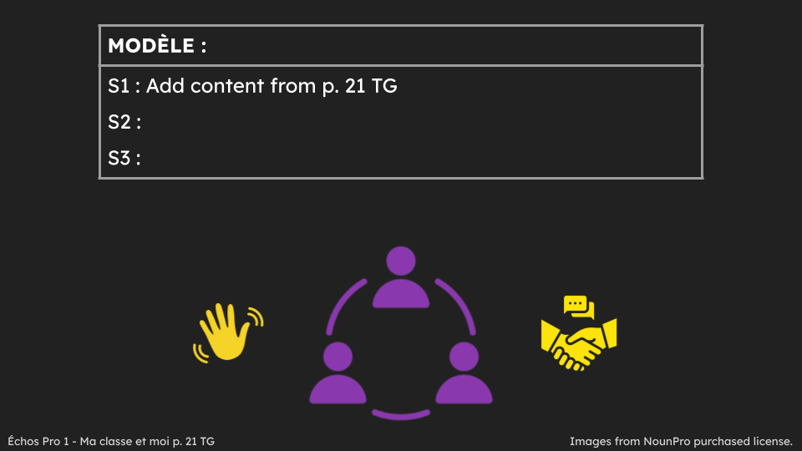 | Je peux me présenter et saluer mes amis.  I can introduce myself and greet my friends. | ☐ Reception  ☐ Production  ☐ Interaction  ☐ Mediation | ☐ Linguistic  ☐ Socio-linguistic  ☐ Pragmatic  ☐ Plurilingualism/  Pluriculturalism | ☐ Listening  ☐ Speaking  ☐ Reading  ☐ Writing
Greeting each other and introducing themselves | Sing along to RLRA video on Youtube: Comment t'appelles tu ? RLRA | Je peux comprendre une chanson.  I can understand a song. | ☐ Reception  ☐ Production  ☐ Interaction  ☐ Mediation | ☐ Linguistic  ☐ Socio-linguistic  ☐ Pragmatic  ☐ Plurilingualism/  Pluriculturalism | ☐ Listening  ☐ Speaking  ☐ Reading  ☐ Writing
Greeting each other and introducing themselves | Inside-outside Circle/Two Lines facing each other (p. 23 TG)  Slideshow - Slide 8  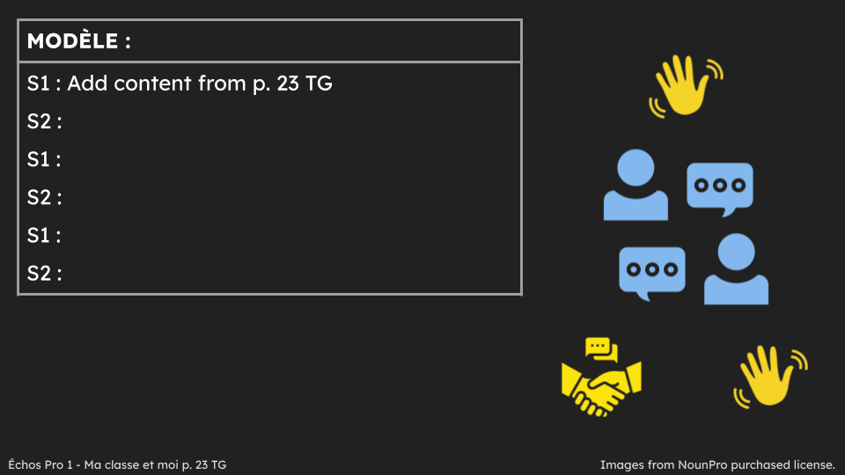 | Je peux me présenter et utiliser des phrases de salutation et de prise de congé simples.  I can introduce myself and use basic greeting and leave-taking expressions. | ☐ Reception  ☐ Production  ☐ Interaction  ☐ Mediation | ☐ Linguistic  ☐ Socio-linguistic  ☐ Pragmatic  ☐ Plurilingualism/  Pluriculturalism | ☐ Listening  ☐ Speaking  ☐ Reading  ☐ Writing
Sharing your own age and the age of your friends | Sing along to RLRA video on Youtube “Quel age as-tu?”  quel age as tu?.m4v | Je peux comprendre une chanson.  I can understand a song. | ☐ Reception  ☐ Production  ☐ Interaction  ☐ Mediation | ☐ Linguistic  ☐ Socio-linguistic  ☐ Pragmatic  ☐ Plurilingualism/  Pluriculturalism | ☐ Listening  ☐ Speaking  ☐ Reading  ☐ Writing
Sharing your own age and the age of your friends | Ask elbow partner their age and share peer’s age with class (p. 31 TG)  Slideshow - Slide 10  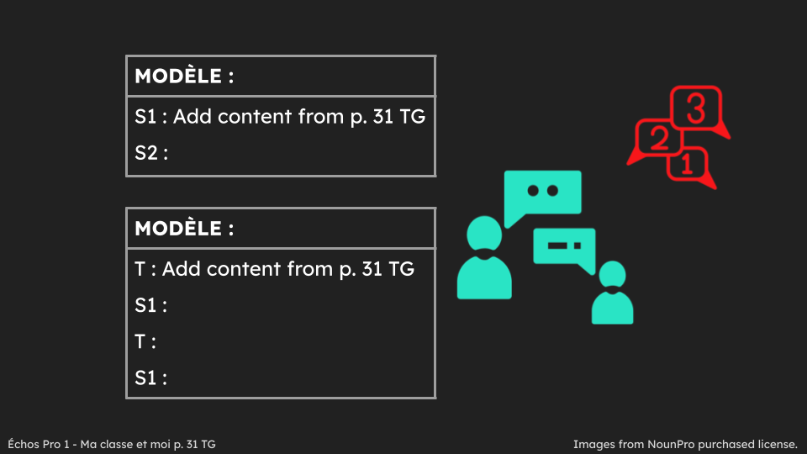 | Je peux dire mon âge et les âges de mes amis.  I can say my age and the ages of my friends. | ☐ Reception  ☐ Production  ☐ Interaction  ☐ Mediation | ☐ Linguistic  ☐ Socio-linguistic  ☐ Pragmatic  ☐ Plurilingualism/  Pluriculturalism | ☐ Listening  ☐ Speaking  ☐ Reading  ☐ Writing
Having a short personal introductory conversation | Mill to Music - when music stops - greet partner, ask & respond to name & age and bid farewell - have pairs share conversation  Slideshow - Slide 11  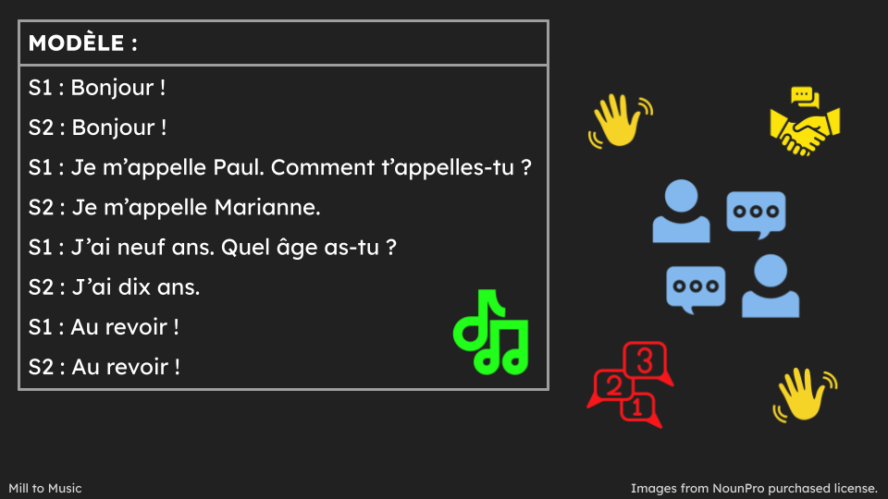 | Je peux avoir une conversation courte avec mes amis.  I can have a small conversation with my friends. | ☐ Reception  ☐ Production  ☐ Interaction  ☐ Mediation | ☐ Linguistic  ☐ Socio-linguistic  ☐ Pragmatic  ☐ Plurilingualism/  Pluriculturalism | ☐ Listening  ☐ Speaking  ☐ Reading  ☐ Writing
Reading and understanding a story | Read and ask questions about the story in module “Bienvenue dans notre classe” (pp. 6-7 text; pp. 27-34 TG) using Modelled Reading, Shared Reading, Guided Reading and Independent Reading | Je peux lire et comprendre une histoire.  I can read and understand a story.  Je peux parler d’un texte.  I can talk about a text. | ☐ Reception  ☐ Production  ☐ Interaction  ☐ Mediation | ☐ Linguistic  ☐ Socio-linguistic  ☐ Pragmatic  ☐ Plurilingualism/  Pluriculturalism | ☐ Listening  ☐ Speaking  ☐ Reading  ☐ Writing

Competence 2: Expressing School Subject Preferences
Sub-task  (Building Competences to Support the Completion of the AO Task) | Possible Activities/ Resources  (e.g., links, slideshows, videos, podcasts, articles, classroom activities) | “I can” / “Je peux”  Statements for Sub-task  (these connect to the “I can statements” on the teacher planning sheet for the AO Task) | Communicative Language Activities/  Strategies (the what) | Communicative Language Competences (the how), and Plurilingualism/  Pluriculturalism | Possible Assessment for Sub-task
Expressing school subject preferences | Go through the class timetable identifying subjects and expressing preferred subjects (pp. 36-37 TG)  Slideshow - Slide 13  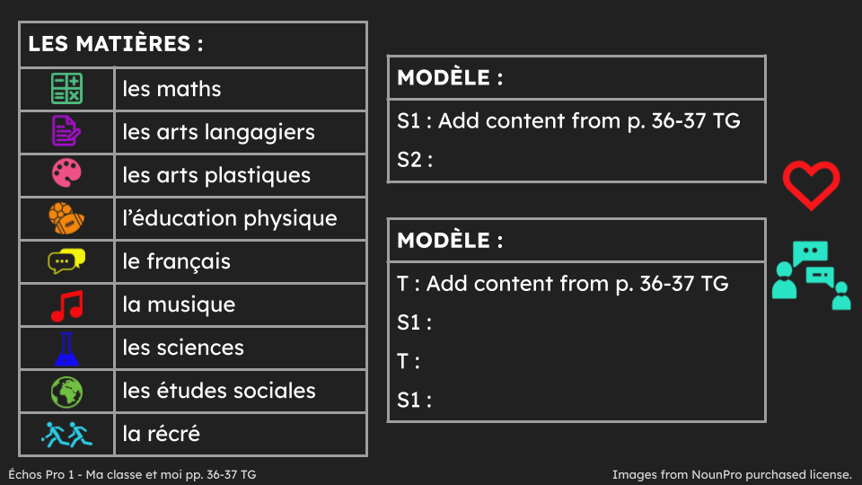 | Je peux exprimer mes matières préférées et les matières préférées de mes ami.es.  I can express my favourite subjects and the favourite subjects of my friends. | ☐ Reception  ☐ Production  ☐ Interaction  ☐ Mediation | ☐ Linguistic  ☐ Socio-linguistic  ☐ Pragmatic  ☐ Plurilingualism/  Pluriculturalism | ☐ Listening  ☐ Speaking  ☐ Reading  ☐ Writing
Building vocabulary related to school objects | Matching Game - display school objects and students guess subject they represent (p. 38 TG) | Je peux identifier les matières.  I can identify school subjects. | ☐ Reception  ☐ Production  ☐ Interaction  ☐ Mediation | ☐ Linguistic  ☐ Socio-linguistic  ☐ Pragmatic  ☐ Plurilingualism/  Pluriculturalism | ☐ Listening  ☐ Speaking  ☐ Reading  ☐ Writing
Building vocabulary related to school objects | Preference chain in groups of 5-6 saying preferred subject and that of peer(s) before.  Slideshow - Slide 14  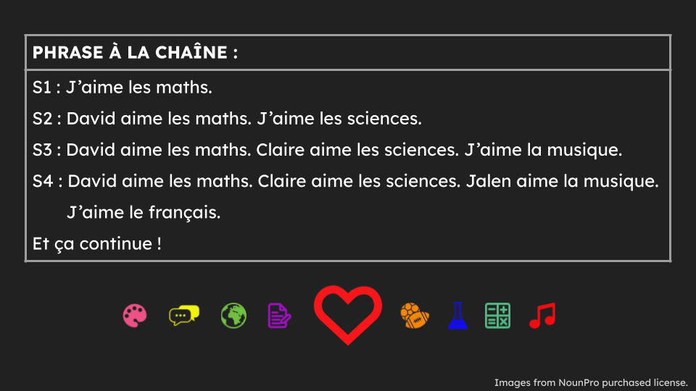 |  | ☐ Reception  ☐ Production  ☐ Interaction  ☐ Mediation | ☐ Linguistic  ☐ Socio-linguistic  ☐ Pragmatic  ☐ Plurilingualism/  Pluriculturalism | ☐ Listening  ☐ Speaking  ☐ Reading  ☐ Writing
Building vocabulary related to school objects | Participating in a game of “Found it / objets trouvés”  Lesson plan with activities  Created by:   | See lesson plan
Reading and understanding the story “Fadia et Manolo à l'école” | Read and ask questions about the story in module “Fadia et Manolo à l'école” (pp. 12-13 text; pp. 35-42 TG) using Modeled Reading, Shared Reading, Guided Reading and Independent Reading | Je peux lire et comprendre une histoire.  I can read and understand a story.  Je peux parler d’un texte.  I can talk about a text. | ☐ Reception  ☐ Production  ☐ Interaction  ☐ Mediation | ☐ Linguistic  ☐ Socio-linguistic  ☐ Pragmatic  ☐ Plurilingualism/  Pluriculturalism | ☐ Listening  ☐ Speaking  ☐ Reading  ☐ Writing
Filling in a school timetable | Complete a class timetable using editable worksheet (p. 41 TG)  FA3 : Mon horaire  (*may want to do one cycle day at a time) | Je peux remplir mon horaire.  I can fill in my class timetable. | ☐ Reception  ☐ Production  ☐ Interaction  ☐ Mediation | ☐ Linguistic  ☐ Socio-linguistic  ☐ Pragmatic  ☐ Plurilingualism/  Pluriculturalism | ☐ Listening  ☐ Speaking  ☐ Reading  ☐ Writing
Learning about school facilities and locations | Lesson and game to express familiarity with school facilities and locations  Lesson plan with activities  Created by: | See lesson plan
Learning about school facilities and locations | Create a school map and send it with a welcome note for a new student  Lesson plan with activities  Created by | See lesson plan
Learning about school facilities and locations |   Give a tour of the school to another person  Subtask overview/Lesson plan with activities | I can name different locations in a school.  Je peux nommer différents endroits dans une école.  I can understand a guided tour of the school.  Je peux comprendre une visite guidée de l’école  I can ask and answer simple questions about a school map.  Je peux poser et répondre à des questions simples sur le plan d’une école. | ☐ Reception  ☐ Production  ☐ Interaction  ☐ Mediation | ☐ Linguistic  ☐ Socio-linguistic  ☐ Pragmatic  ☐ Plurilingualism/  Pluriculturalism | ☐ Listening  ☐ Speaking  ☐ Reading  ☐ Writing

Competence 3: Expressing Colour Preferences
Sub-task  (Building Competences to Support the Completion of the AO Task) | Possible Activities/ Resources  (e.g., links, slideshows, videos, podcasts, articles, classroom activities) | “I can” / “Je peux”  Statements for Sub-task  (these connect to the “I can statements” on the teacher planning sheet for the AO Task) | Communicative Language Activities/  Strategies (the what) | Communicative Language Competences (the how), and Plurilingualism/  Pluriculturalism | Possible Assessment for Sub-task
Identifying colours and sharing colour preferences | Identify colours heard in RLRA video on Youtube : Quelle couleur aimes tu ? RLRA | Je peux identifier les couleurs.  I can identify couleurs.  Je peux comprendre une chanson.  I can understand a song. | ☐ Reception  ☐ Production  ☐ Interaction  ☐ Mediation | ☐ Linguistic  ☐ Socio-linguistic  ☐ Pragmatic  ☐ Plurilingualism/  Pluriculturalism | ☐ Listening  ☐ Speaking  ☐ Reading  ☐ Writing
Identifying colours and sharing colour preferences | Greet elbow partner, expressing colour preferences (pp. 44-45 TG)  Slideshow - Slide 17  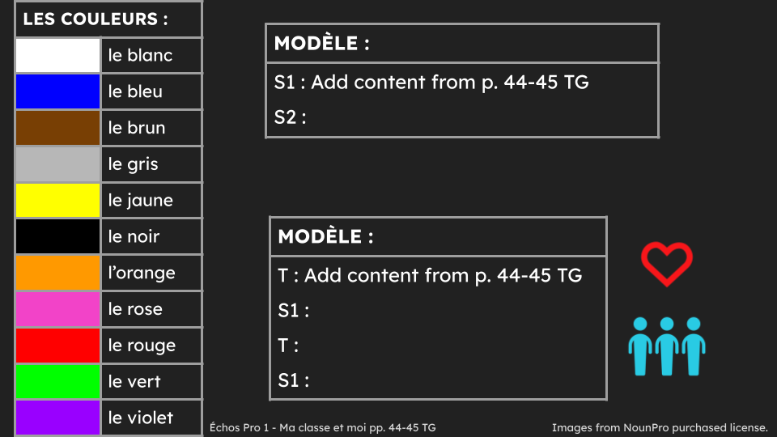 | Je peux exprimer ma couleur préférée et la couleur préférée de mon ami.  I can express my favourite colour and the favourite colour of my friend. | ☐ Reception  ☐ Production  ☐ Interaction  ☐ Mediation | ☐ Linguistic  ☐ Socio-linguistic  ☐ Pragmatic  ☐ Plurilingualism/  Pluriculturalism | ☐ Listening  ☐ Speaking  ☐ Reading  ☐ Writing
Identifying colours and sharing colour preferences | Survey - display images of coloured backpacks, line up in front of favourite colour, expressing colour preferences (p. 46 TG) | Je peux exprimer ma couleur préférée et la couleur préférée de mes amis.  I can express my favourite colour and the favourite colour of my friends. | ☐ Reception  ☐ Production  ☐ Interaction  ☐ Mediation | ☐ Linguistic  ☐ Socio-linguistic  ☐ Pragmatic  ☐ Plurilingualism/  Pluriculturalism | ☐ Listening  ☐ Speaking  ☐ Reading  ☐ Writing
Reading and understanding the story “Où est mon sac à dos?” | Read and ask questions about the story in the module “Où est mon sac à dos?” (pp. 14-15 text; pp. 43-49 TG) using Modelled Reading, Shared Reading, Guided Reading and Independent Reading | Je peux lire et comprendre une histoire.  I can read and understand a story.  Je peux parler d’un texte.  I can talk about a text. | ☐ Reception  ☐ Production  ☐ Interaction  ☐ Mediation | ☐ Linguistic  ☐ Socio-linguistic  ☐ Pragmatic  ☐ Plurilingualism/  Pluriculturalism | ☐ Listening  ☐ Speaking  ☐ Reading  ☐ Writing
Describing backpack colours | Students share colour of backpack, then practise with 5 other students in the class | Je peux décrire la couleur de mon sac à dos.  I can describe the colour of my backpack. | ☐ Reception  ☐ Production  ☐ Interaction  ☐ Mediation | ☐ Linguistic  ☐ Socio-linguistic  ☐ Pragmatic  ☐ Plurilingualism/  Pluriculturalism | ☐ Listening  ☐ Speaking  ☐ Reading  ☐ Writing
Building vocabulary related to subjects and colours using listening activities | Listen to audio (pp. 48-49 TG)  É5 : Quel sac à dos ?  to complete worksheet  FA5 : Quel sac à dos ? | Je peux comprendre un texte oral.  I can understand an oral text.  Je peux identifier la matière préférée et la couleur du sac à dos d'un texte oral.  I can identify the favourite subject and backpack colour from an oral text. | ☐ Reception  ☐ Production  ☐ Interaction  ☐ Mediation | ☐ Linguistic  ☐ Socio-linguistic  ☐ Pragmatic  ☐ Plurilingualism/  Pluriculturalism | ☐ Listening  ☐ Speaking  ☐ Reading  ☐ Writing

Competence 4: Sharing the Personal Information of Others
Sub-task  (Building Competences to Support the Completion of the AO Task) | Possible Activities/ Resources  (e.g., links, slideshows, videos, podcasts, articles, classroom activities) | “I can” / “Je peux”  Statements for Sub-task  (these connect to the “I can statements” on the teacher planning sheet for the AO Task) | Communicative Language Activities/  Strategies (the what) | Communicative Language Competences (the how), and Plurilingualism/  Pluriculturalism | Possible Assessment for Sub-task
Greeting each other in more than one language | Ask elbow partner how they say “hello” and share those ways with class (pp. 56-57 TG) | Je peux dire “bonjour” dans des langues différentes et comment mon ami dit “bonjour”.  I can greet others in different languages and say how my friend greets others. | ☐ Reception  ☐ Production  ☐ Interaction  ☐ Mediation | ☐ Linguistic  ☐ Socio-linguistic  ☐ Pragmatic  ☐ Plurilingualism/  Pluriculturalism | ☐ Listening  ☐ Speaking  ☐ Reading  ☐ Writing
Greeting each other in more than one language | Watch and ask questions about module video “Je présente mes amis” (p. 18-19 text: pp. 57-58 TG) | Je peux comprendre une vidéo.  I can understand a video.  Je peux identifier les noms des amis et comment ils disent “bonjour”.  I can identify names and ways they said “hello”. | ☐ Reception  ☐ Production  ☐ Interaction  ☐ Mediation | ☐ Linguistic  ☐ Socio-linguistic  ☐ Pragmatic  ☐ Plurilingualism/  Pluriculturalism | ☐ Listening  ☐ Speaking  ☐ Reading  ☐ Writing
Greeting each other in more than one language | Survey - record ways students say “hello” in different languages - noting number of speakers for each language (p. 58 TG) | Je peux dire “bonjour” dans des langues différentes et comment mes amis disent “bonjour”.  I can greet others in different languages and say how my friends greet others. | ☐ Reception  ☐ Production  ☐ Interaction  ☐ Mediation | ☐ Linguistic  ☐ Socio-linguistic  ☐ Pragmatic  ☐ Plurilingualism/  Pluriculturalism | ☐ Listening  ☐ Speaking  ☐ Reading  ☐ Writing
Identifying basic personal information, preferences and languages spoken | Role-play reporter asking peers basic personal information & preferences (p. 56 TG) | Je peux identifier des informations personnelles, les préférences et les langues parlées de mes ami.e.s.  I can identify personal information, preferences and languages spoken by my friends. | ☐ Reception  ☐ Production  ☐ Interaction  ☐ Mediation | ☐ Linguistic  ☐ Socio-linguistic  ☐ Pragmatic  ☐ Plurilingualism/  Pluriculturalism | ☐ Listening  ☐ Speaking  ☐ Reading  ☐ Writing
 | Watch module video “Je présente mes amis” again (p. 18-19 text) and complete worksheet  FA7 : Des entrevues  by recording information from video (p. 60 TG) | Je peux identifier des informations personnelles, les préférences et les langues parlées d’un clip.  I can identify personal information, preferences and languages spoken in the video. | ☐ Reception  ☐ Production  ☐ Interaction  ☐ Mediation | ☐ Linguistic  ☐ Socio-linguistic  ☐ Pragmatic  ☐ Plurilingualism/  Pluriculturalism | ☐ Listening  ☐ Speaking  ☐ Reading  ☐ Writing
 | Get signatures- find peers who have same information, complete worksheet (pp. 62-63 TG)  FA8 : Je pose des questions | Je peux poser des questions personnelles et répondre aux questions personnelles.  I can ask and respond to personal questions. | ☐ Reception  ☐ Production  ☐ Interaction  ☐ Mediation | ☐ Linguistic  ☐ Socio-linguistic  ☐ Pragmatic  ☐ Plurilingualism/  Pluriculturalism | ☐ Listening  ☐ Speaking  ☐ Reading  ☐ Writing
 | Complete phrases with personal information and images on  worksheet:  FA1 : Je me présente | Je peux écrire des informations personnelles, mes préférences et comment je dis “bonjour”.  I can write about my personal information, preferences and how I say “hello”. | ☐ Reception  ☐ Production  ☐ Interaction  ☐ Mediation | ☐ Linguistic  ☐ Socio-linguistic  ☐ Pragmatic  ☐ Plurilingualism/  Pluriculturalism | ☐ Listening  ☐ Speaking  ☐ Reading  ☐ Writing
Building vocabulary related to greetings and personal information | Listen to the module song Chanson : Bonjour ! Salut ! (pp. 20-21 text) for familiar words and phrases | Je peux identifier les mots familiers d’une chanson.  I can identify familiar words in a song.  Je peux comprendre une chanson.  I can understand a song. | ☐ Reception  ☐ Production  ☐ Interaction  ☐ Mediation | ☐ Linguistic  ☐ Socio-linguistic  ☐ Pragmatic  ☐ Plurilingualism/  Pluriculturalism | ☐ Listening  ☐ Speaking  ☐ Reading  ☐ Writing
 | Listen to the module song Chanson : Bonjour ! Salut ! again (pp. 20-21 text) and stand when phrase/image is heard from worksheet (p. 67 TG)  FA9 : Bonjour ! Salut ! | Je peux identifier les mots familiers d’une chanson.  I can identify familiar words in a song.  Je peux comprendre une chanson.  I can understand a song. | ☐ Reception  ☐ Production  ☐ Interaction  ☐ Mediation | ☐ Linguistic  ☐ Socio-linguistic  ☐ Pragmatic  ☐ Plurilingualism/  Pluriculturalism | ☐ Listening  ☐ Speaking  ☐ Reading  ☐ Writing
 | Listen to the module song Chanson : Bonjour ! Salut ! again (pp. 20-21 text) and ask questions for understanding of personal information | Je peux comprendre des informations personnelles d’une chanson.  I understand the personal information shared in a song. | ☐ Reception  ☐ Production  ☐ Interaction  ☐ Mediation | ☐ Linguistic  ☐ Socio-linguistic  ☐ Pragmatic  ☐ Plurilingualism/  Pluriculturalism | ☐ Listening  ☐ Speaking  ☐ Reading  ☐ Writing

Competence 5: Engaging in Conversation with Others
Sub-task  (Building Competences to Support the Completion of the AO Task) | Possible Activities/ Resources  (e.g., links, slideshows, videos, podcasts, articles, classroom activities) | “I can” / “Je peux”  Statements for Sub-task  (these connect to the “I can statements” on the teacher planning sheet for the AO Task) | Communicative Language Activities/  Strategies (the what) | Communicative Language Competences (the how), and Plurilingualism/  Pluriculturalism | Possible Assessment for Sub-task
Asking and responding to a friend in a conversation | Find the match - strips from worksheet “Trouve le match” (available in the next pages)  students read strip and try to find response that corresponds - once pairs have found match - have each read it aloud to class - repeat activity with students having a different strip | Je peux lire et comprendre des questions et des réponses.  I can read and understand questions and responses. | ☐ Reception  ☐ Production  ☐ Interaction  ☐ Mediation | ☐ Linguistic  ☐ Socio-linguistic  ☐ Pragmatic  ☐ Plurilingualism/  Pluriculturalism | ☐ Listening  ☐ Speaking  ☐ Reading  ☐ Writing
Expressing time | Mill to Music & Information Exchange - strips from worksheet “Échange d'informations” (available in the next pages)  and students use time expressions to describe daily agenda, then exchange strips and repeat with new strip when music stops again | Je peux décrire l’horaire avec les expressions de temps.  I can describe the agenda using time expressions. | ☐ Reception  ☐ Production  ☐ Interaction  ☐ Mediation | ☐ Linguistic  ☐ Socio-linguistic  ☐ Pragmatic  ☐ Plurilingualism/  Pluriculturalism | ☐ Listening  ☐ Speaking  ☐ Reading  ☐ Writing
Beginning and ending a conversation | Smiley Face/Sad Face - print or draw large happy face and sad face - students move around - teacher holds up face, students stop, find close partner and practise a greeting expression if happy face or a leave-taking expression if sad face - then, repeat  Slideshow - Slide 20  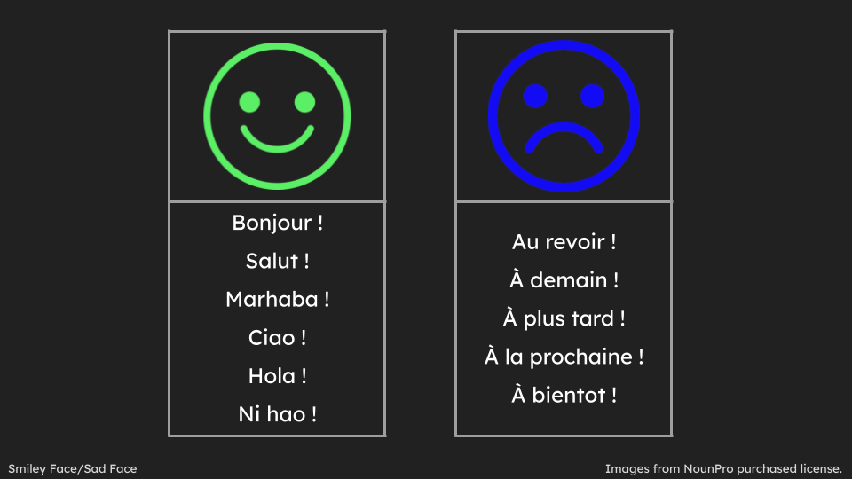 | Je peux utiliser des phrases de salutation et de prise de congé simples.  I can use basic greeting and leave-taking expressions. | ☐ Reception  ☐ Production  ☐ Interaction  ☐ Mediation | ☐ Linguistic  ☐ Socio-linguistic  ☐ Pragmatic  ☐ Plurilingualism/  Pluriculturalism | ☐ Listening  ☐ Speaking  ☐ Reading  ☐ Writing

Resources for the Classroom to Support the Threads

Slideshow
Click twice on the presentation to view all slides. This presentation is also available online by clicking here.


Trouve le match
✂
Comment t’appelles-tu ? | Je m’appelle …
Quel âge as-tu ? | J’ai … ans.
Quelle matière est-ce que tu aimes ? | J’aime …
Quelle couleur est-ce que tu aimes ? | J’aime …
Comment est-ce que tu dis “bonjour” ? | Je dis …
Est-ce que tu veux jouer avec moi ? | Oui, merci.
Est-ce que je peux t’aider ? | Oui, s’il vous plaît.
Où est ton horaire ? | C’est dans mon sac à dos.
De quelle couleur est ton sac à dos ? | Mon sac à dos est …

Échange d'informations
✂
Après la récré, c’est … | Après le dîner, c’est …
Après les sciences, c’est … | À 9h00, c’est …
Après les maths, c’est … | À 10h00, c’est …
Après le français, c’est … | À 11h10, c’est …
Après la musique, c’est … | À 1h00, c’est …
Après l'éducation physique, c’est … | À 2h05, c’est …
Après …, c’est … | À 3h00, c’est …

