
SUB-TASKS RELATED TO:
CEFR EASTERN ONTARIO
Engaging in Conversation with Others

Sub-task  (Building Competences to Support the Completion of the AO Task) | Possible Activities/ Resources  (e.g., links, slideshows, videos, podcasts, articles, classroom activities) | “I can” / “Je peux”  Statements for Sub-task  (these connect to the “I can statements” on the teacher planning sheet for the AO Task) | Communicative Language Activities/  Strategies (the what) | Communicative Language Competences (the how), and Plurilingualism/  Pluriculturalism | Possible Assessment for Sub-task
Asking and responding to a friend in a conversation | Find the match - strips from worksheet  Trouve le match  students read strip and try to find response that corresponds - once pairs have found match - have each read it aloud to class - repeat activity with students having a different strip | Je peux lire et comprendre des questions et des réponses.  I can read and understand questions and responses. | ☐ Reception  ☐ Production  ☐ Interaction  ☐ Mediation | ☐ Linguistic  ☐ Socio-linguistic  ☐ Pragmatic  ☐ Plurilingualism/  Pluriculturalism | ☐ Listening  ☐ Speaking  ☐ Reading  ☐ Writing
Expressing time | Mill to Music & Information Exchange - strips from worksheet  Échange d'informations  and students use time expressions to describe daily agenda, then exchange strips and repeat with new strip when music stops again | Je peux décrire l’horaire avec les expressions de temps.  I can describe the agenda using time expressions. | ☐ Reception  ☐ Production  ☐ Interaction  ☐ Mediation | ☐ Linguistic  ☐ Socio-linguistic  ☐ Pragmatic  ☐ Plurilingualism/  Pluriculturalism | ☐ Listening  ☐ Speaking  ☐ Reading  ☐ Writing
Beginning and ending a conversation | Smiley Face/Sad Face - print or draw large happy face and sad face - students move around - teacher holds up face, students stop, find close partner and practise a greeting expression if happy face or a leave-taking expression if sad face - then, repeat  Slideshow - Slide 20  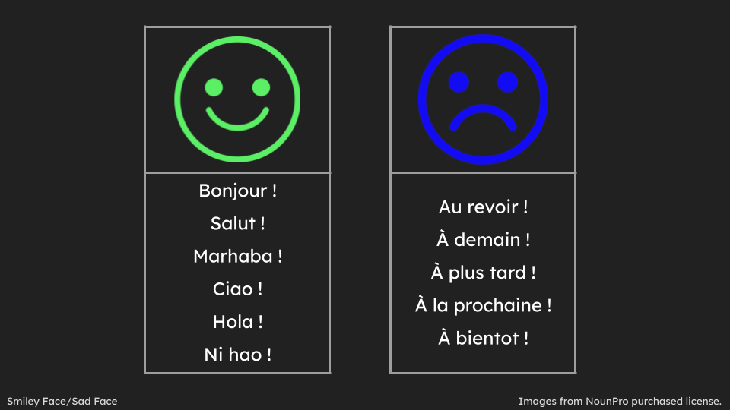 | Je peux utiliser des phrases de salutation et de prise de congé simples.  I can use basic greeting and leave-taking expressions. | ☐ Reception  ☐ Production  ☐ Interaction  ☐ Mediation | ☐ Linguistic  ☐ Socio-linguistic  ☐ Pragmatic  ☐ Plurilingualism/  Pluriculturalism | ☐ Listening  ☐ Speaking  ☐ Reading  ☐ Writing
* It is up to teachers to determine whether the sub-tasks are assessments FOR learning, OF learning, or AS learning.

