
SUB-TASKS RELATED TO:
CEFR EASTERN ONTARIO
Expressing Colour Preferences

Sub-task  (Building Competences to Support the Completion of the AO Task) | Possible Activities/ Resources  (e.g., links, slideshows, videos, podcasts, articles, classroom activities) | “I can” / “Je peux”  Statements for Sub-task  (these connect to the “I can statements” on the teacher planning sheet for the AO Task) | Communicative Language Activities/  Strategies (the what) | Communicative Language Competences (the how), and Plurilingualism/  Pluriculturalism | Possible Assessment for Sub-task
Identifying colours and sharing colour preferences | Identify colours heard in RLRA video on Youtube “Quelle couleur aimes-tu?” Quelle couleur aimes tu ? RLRA | Je peux identifier les couleurs.  I can identify couleurs.  Je peux comprendre une chanson.  I can understand a song. | ☐ Reception  ☐ Production  ☐ Interaction  ☐ Mediation | ☐ Linguistic  ☐ Socio-linguistic  ☐ Pragmatic  ☐ Plurilingualism/  Pluriculturalism | ☐ Listening  ☐ Speaking  ☐ Reading  ☐ Writing
Identifying colours and sharing colour preferences | Greet elbow partner, expressing colour preferences (pp. 44-45 TG)  Slideshow - Slide 17  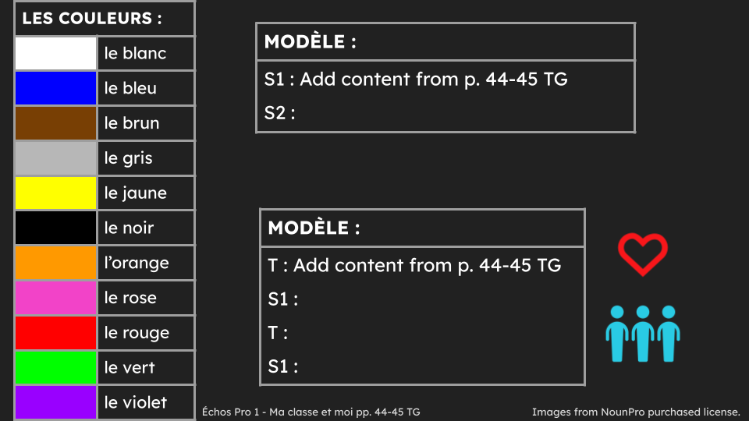 | Je peux exprimer ma couleur préférée et la couleur préférée de mon ami.  I can express my favourite colour and the favourite colour of my friend. | ☐ Reception  ☐ Production  ☐ Interaction  ☐ Mediation | ☐ Linguistic  ☐ Socio-linguistic  ☐ Pragmatic  ☐ Plurilingualism/  Pluriculturalism | ☐ Listening  ☐ Speaking  ☐ Reading  ☐ Writing
Identifying colours and sharing colour preferences | Survey - display images of coloured backpacks, line up in front of favourite colour, expressing colour preferences (p. 46 TG) | Je peux exprimer ma couleur préférée et la couleur préférée de mes amis.  I can express my favourite colour and the favourite colour of my friends. | ☐ Reception  ☐ Production  ☐ Interaction  ☐ Mediation | ☐ Linguistic  ☐ Socio-linguistic  ☐ Pragmatic  ☐ Plurilingualism/  Pluriculturalism | ☐ Listening  ☐ Speaking  ☐ Reading  ☐ Writing
Reading and understanding the story “Où est mon sac à dos?” | Read and ask questions about the story in the module “Où est mon sac à dos?” (pp. 14-15 text; pp. 43-49 TG) using Modelled Reading, Shared Reading, Guided Reading and Independent Reading | Je peux lire et comprendre une histoire.  I can read and understand a story.  Je peux parler d’un texte.  I can talk about a text. | ☐ Reception  ☐ Production  ☐ Interaction  ☐ Mediation | ☐ Linguistic  ☐ Socio-linguistic  ☐ Pragmatic  ☐ Plurilingualism/  Pluriculturalism | ☐ Listening  ☐ Speaking  ☐ Reading  ☐ Writing
Describing backpack colours | Students share colour of backpack, then practise with 5 other students in the class | Je peux décrire la couleur de mon sac à dos.  I can describe the colour of my backpack. | ☐ Reception  ☐ Production  ☐ Interaction  ☐ Mediation | ☐ Linguistic  ☐ Socio-linguistic  ☐ Pragmatic  ☐ Plurilingualism/  Pluriculturalism | ☐ Listening  ☐ Speaking  ☐ Reading  ☐ Writing
Building vocabulary related to subjects and colours using listening activities | Listen to audio (pp. 48-49 TG)  É5 : Quel sac à dos ?  to complete worksheet  FA5 : Quel sac à dos ? | Je peux comprendre un texte oral.  I can understand an oral text.  Je peux identifier la matière préférée et la couleur du sac à dos d'un texte oral.  I can identify the favourite subject and backpack colour from an oral text. | ☐ Reception  ☐ Production  ☐ Interaction  ☐ Mediation | ☐ Linguistic  ☐ Socio-linguistic  ☐ Pragmatic  ☐ Plurilingualism/  Pluriculturalism | ☐ Listening  ☐ Speaking  ☐ Reading  ☐ Writing
* It is up to teachers to determine whether the sub-tasks are assessments FOR learning, OF learning, or AS learning.

