
SUB-TASKS RELATED TO:
CEFR EASTERN ONTARIO
Expressing School Subject Preferences/Exploring a School

Sub-task  (Building Competences to Support the Completion of the AO Task) | Possible Activities/ Resources  (e.g., links, slideshows, videos, podcasts, articles, classroom activities) | “I can” / “Je peux”  Statements for Sub-task  (these connect to the “I can statements” on the teacher planning sheet for the AO Task) | Communicative Language Activities/  Strategies (the what) | Communicative Language Competences (the how), and Plurilingualism/  Pluriculturalism | Possible Assessment for Sub-task
Expressing school subject preferences | Go through the class timetable identifying subjects and expressing preferred subjects (pp. 36-37 TG)  Slideshow - Slide 13  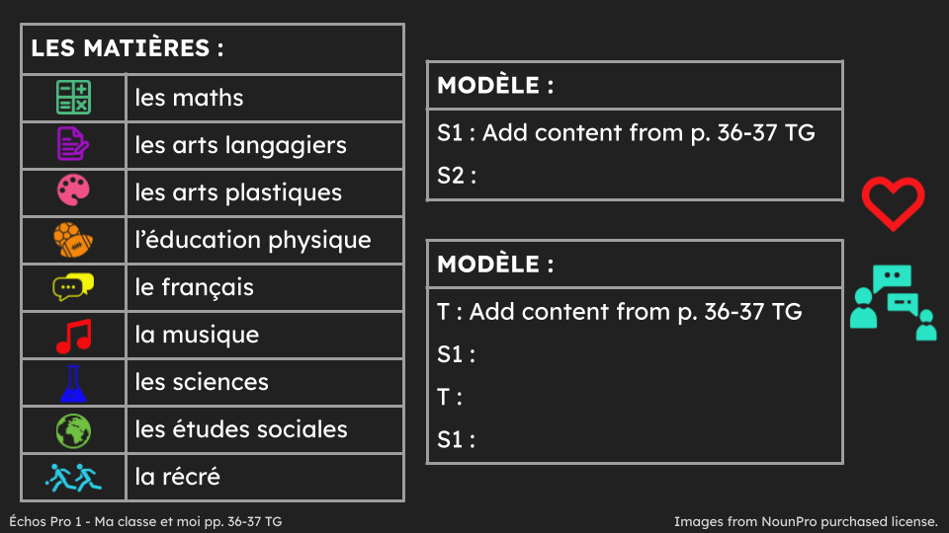 | Je peux exprimer mes matières préférées et les matières préférées de mes ami.es.  I can express my favourite subjects and the favourite subjects of my friends. | ☐ Reception  ☐ Production  ☐ Interaction  ☐ Mediation | ☐ Linguistic  ☐ Socio-linguistic  ☐ Pragmatic  ☐ Plurilingualism/  Pluriculturalism | ☐ Listening  ☐ Speaking  ☐ Reading  ☐ Writing
Building vocabulary related to school objects | Matching Game - display school objects and students guess subject they represent (p. 38 TG) | Je peux identifier les matières.  I can identify school subjects. | ☐ Reception  ☐ Production  ☐ Interaction  ☐ Mediation | ☐ Linguistic  ☐ Socio-linguistic  ☐ Pragmatic  ☐ Plurilingualism/  Pluriculturalism | ☐ Listening  ☐ Speaking  ☐ Reading  ☐ Writing
Building vocabulary related to school objects | Preference chain in groups of 5-6 saying preferred subject and that of peer(s) before.  Slideshow - Slide 14  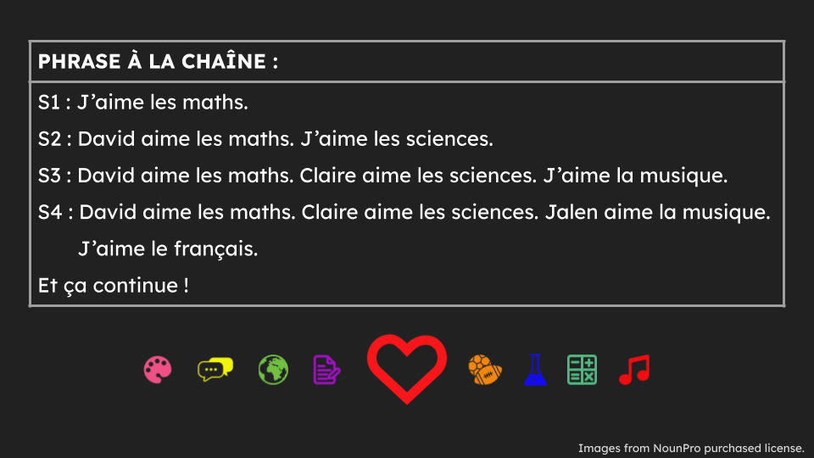 |  | ☐ Reception  ☐ Production  ☐ Interaction  ☐ Mediation | ☐ Linguistic  ☐ Socio-linguistic  ☐ Pragmatic  ☐ Plurilingualism/  Pluriculturalism | ☐ Listening  ☐ Speaking  ☐ Reading  ☐ Writing
Building vocabulary related to school objects | Participating in a game of “Found it / objets trouvés”  Lesson plan with activities  Created by:   | See lesson plan
Reading and understanding the story “Fadia et Manolo à l'école” | Read and ask questions about the story in module “Fadia et Manolo à l'école” (pp. 12-13 text; pp. 35-42 TG) using Modeled Reading, Shared Reading, Guided Reading and Independent Reading | Je peux lire et comprendre une histoire.  I can read and understand a story.  Je peux parler d’un texte.  I can talk about a text. | ☐ Reception  ☐ Production  ☐ Interaction  ☐ Mediation | ☐ Linguistic  ☐ Socio-linguistic  ☐ Pragmatic  ☐ Plurilingualism/  Pluriculturalism | ☐ Listening  ☐ Speaking  ☐ Reading  ☐ Writing
Filling in a school timetable | Complete a class timetable using editable worksheet (p. 41 TG)  FA3 : Mon horaire  (*may want to do one cycle day at a time) | Je peux remplir mon horaire.  I can fill in my class timetable. | ☐ Reception  ☐ Production  ☐ Interaction  ☐ Mediation | ☐ Linguistic  ☐ Socio-linguistic  ☐ Pragmatic  ☐ Plurilingualism/  Pluriculturalism | ☐ Listening  ☐ Speaking  ☐ Reading  ☐ Writing
Learning about school facilities and locations | Lesson and game to express familiarity with school facilities and locations  Lesson plan with activities  Created by: | See lesson plan
Learning about school facilities and locations | Create a school map and send it with a welcome note for a new student  Lesson plan with activities  Created by: | See lesson plan
Learning about school facilities and locations |   Give a tour of the school to another person  Subtask overview/Lesson plan with activities | I can name different locations in a school.  Je peux nommer différents endroits dans une école.  I can understand a guided tour of the school.  Je peux comprendre une visite guidée de l’école  I can ask and answer simple questions about a school map.  Je peux poser et répondre à des questions simples sur le plan d’une école. | ☐ Reception  ☐ Production  ☐ Interaction  ☐ Mediation | ☐ Linguistic  ☐ Socio-linguistic  ☐ Pragmatic  ☐ Plurilingualism/  Pluriculturalism | ☐ Listening  ☐ Speaking  ☐ Reading  ☐ Writing
* It is up to teachers to determine whether the sub-tasks are assessments FOR learning, OF learning, or AS learning.

