
SUB-TASKS RELATED TO:
CEFR EASTERN ONTARIO
Sharing Personal Information

Sub-task  (Building Competences to Support the Completion of the AO Task) | Possible Activities/ Resources  (e.g., links, slideshows, videos, podcasts, articles, classroom activities) | “I can” / “Je peux”  Statements for Sub-task  (these connect to the “I can statements” on the teacher planning sheet for the AO Task) | Communicative Language Activities/  Strategies (the what) | Communicative Language Competences (the how), and Plurilingualism/  Pluriculturalism | Possible Assessment for Sub-task
Greeting each other and introducing themselves | Students are in a circle and do a bean bag toss (p. 21 TG)  Slideshow - Slide 5  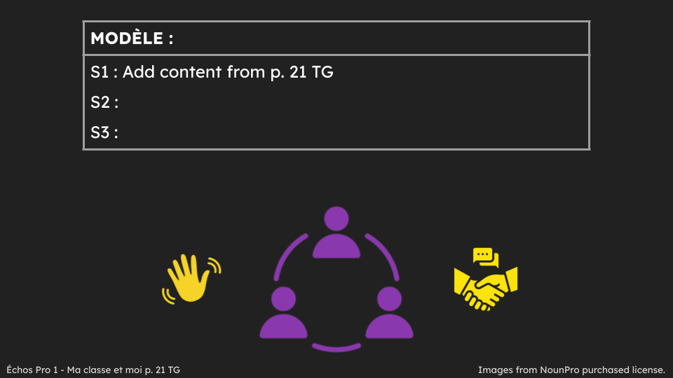 | Je peux me présenter et saluer mes amis.  I can introduce myself and greet my friends. | ☐ Reception  ☐ Production  ☐ Interaction  ☐ Mediation | ☐ Linguistic  ☐ Socio-linguistic  ☐ Pragmatic  ☐ Plurilingualism/  Pluriculturalism | ☐ Listening  ☐ Speaking  ☐ Reading  ☐ Writing
Greeting each other and introducing themselves | Sing along to RLRA video on Youtube “Comment t’appelles-tu?”  Comment t'appelles tu ? RLRA | Je peux comprendre une chanson.  I can understand a song. | ☐ Reception  ☐ Production  ☐ Interaction  ☐ Mediation | ☐ Linguistic  ☐ Socio-linguistic  ☐ Pragmatic  ☐ Plurilingualism/  Pluriculturalism | ☐ Listening  ☐ Speaking  ☐ Reading  ☐ Writing
Greeting each other and introducing themselves | Inside-outside Circle/Two Lines facing each other (p. 23 TG)  Slideshow - Slide 8  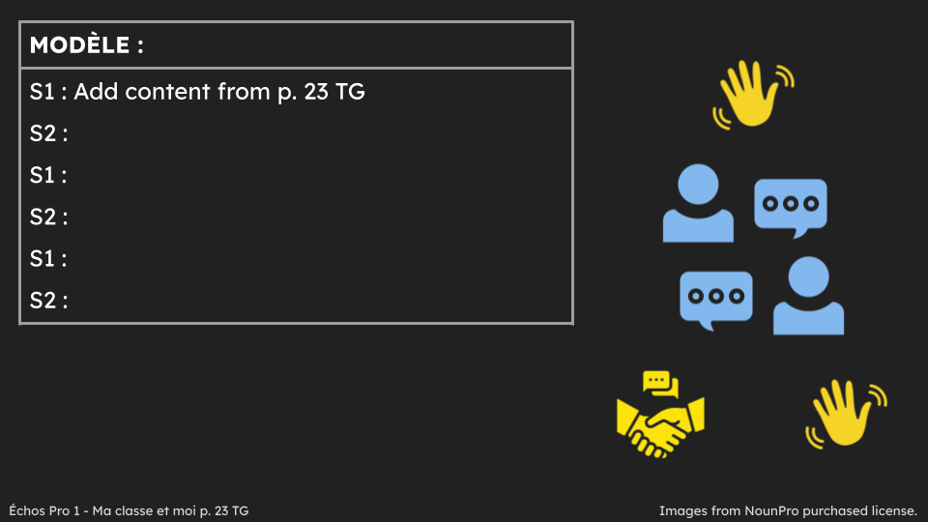 | Je peux me présenter et utiliser des phrases de salutation et de prise de congé simples.  I can introduce myself and use basic greeting and leave-taking expressions. | ☐ Reception  ☐ Production  ☐ Interaction  ☐ Mediation | ☐ Linguistic  ☐ Socio-linguistic  ☐ Pragmatic  ☐ Plurilingualism/  Pluriculturalism | ☐ Listening  ☐ Speaking  ☐ Reading  ☐ Writing
Sharing your own age and the age of your friends | Sing along to RLRA video on Youtube “Quel age as-tu?”  quel age as tu?.m4v | Je peux comprendre une chanson.  I can understand a song. | ☐ Reception  ☐ Production  ☐ Interaction  ☐ Mediation | ☐ Linguistic  ☐ Socio-linguistic  ☐ Pragmatic  ☐ Plurilingualism/  Pluriculturalism | ☐ Listening  ☐ Speaking  ☐ Reading  ☐ Writing
Sharing your own age and the age of your friends | Ask elbow partner their age and share peer’s age with class (p. 31 TG)  Slideshow - Slide 10  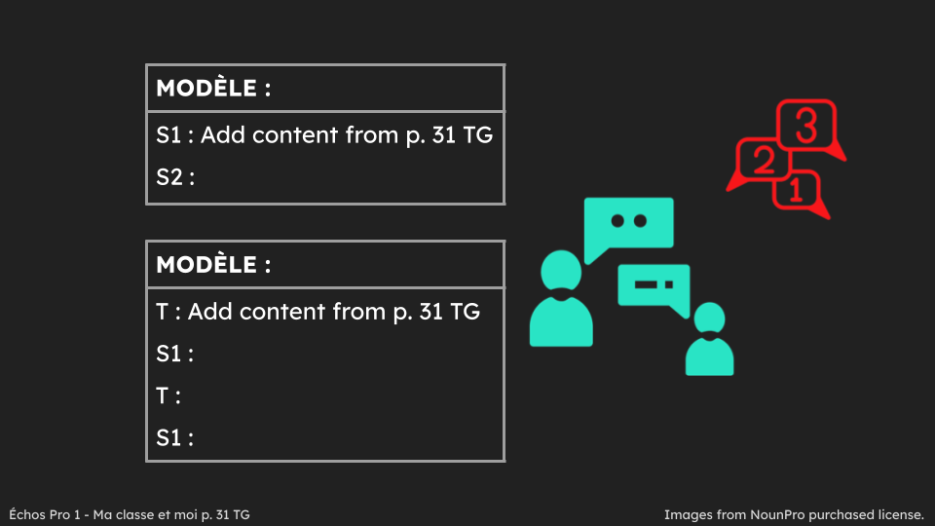 | Je peux dire mon âge et les âges de mes amis.  I can say my age and the ages of my friends. | ☐ Reception  ☐ Production  ☐ Interaction  ☐ Mediation | ☐ Linguistic  ☐ Socio-linguistic  ☐ Pragmatic  ☐ Plurilingualism/  Pluriculturalism | ☐ Listening  ☐ Speaking  ☐ Reading  ☐ Writing
Having a short personal introductory conversation | Mill to Music - when music stops - greet partner, ask & respond to name & age and bid farewell - have pairs share conversation  Slideshow - Slide 11  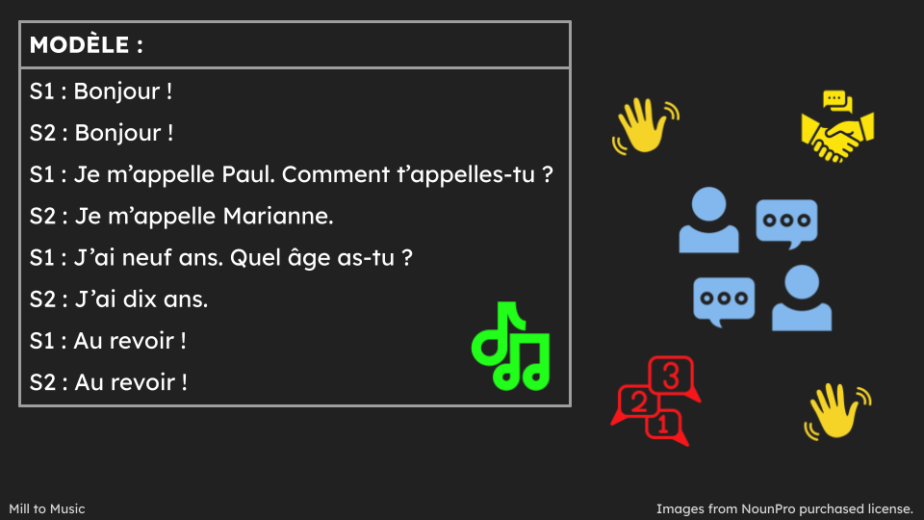 | Je peux avoir une conversation courte avec mes amis.  I can have a small conversation with my friends. | ☐ Reception  ☐ Production  ☐ Interaction  ☐ Mediation | ☐ Linguistic  ☐ Socio-linguistic  ☐ Pragmatic  ☐ Plurilingualism/  Pluriculturalism | ☐ Listening  ☐ Speaking  ☐ Reading  ☐ Writing
Reading and understanding a story | Read and ask questions about the story in module “Bienvenue dans notre classe” (pp. 6-7 text; pp. 27-34 TG) using Modelled Reading, Shared Reading, Guided Reading and Independent Reading | Je peux lire et comprendre une histoire.  I can read and understand a story.  Je peux parler d’un texte.  I can talk about a text. | ☐ Reception  ☐ Production  ☐ Interaction  ☐ Mediation | ☐ Linguistic  ☐ Socio-linguistic  ☐ Pragmatic  ☐ Plurilingualism/  Pluriculturalism | ☐ Listening  ☐ Speaking  ☐ Reading  ☐ Writing
* It is up to teachers to determine whether the sub-tasks are assessments FOR learning, OF learning, or AS learning.

